## Nielsen Heuristics Evaluation Form (make as many copies as you need)

**1. What screen of the UI are you looking at (attach/paste a picture/screenshot):**

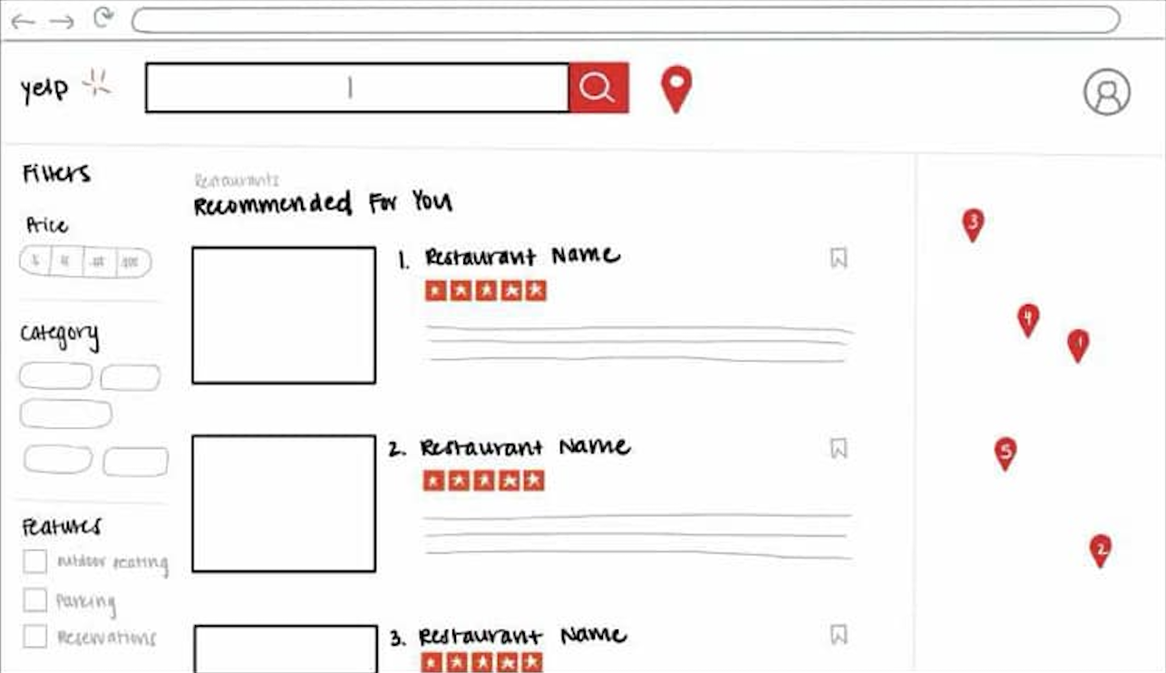

**2. Evaluate each heuristic below for this screen. Feel free to draw circles and arrows around the above screen shot.**

* Visibility of System Status:

**The interface provides clear indications of results being displayed, with restaurants listed in the "Recommended For You" section. The interactive map on the right enhances visibility by showing corresponding location markers for each restaurant. However, there is no visual feedback (e.g., loading spinner) if results are being processed.**

* Match Between System and Real World

**The design uses real-world terminology (e.g., "Price," "Category," "Features") and visual cues such as location markers on a map. This aligns with how users would typically browse for restaurants. The inclusion of filters is intuitive for narrowing options.**

* User Control and Freedom

**Users can refine their search through filters (e.g., price, features like parking or outdoor seating), bookmark options, and view locations on a map. However, there is no visible "reset filters" button, which would improve control and freedom when exploring multiple options.**

* Consistency and Standards

**The interface follows a consistent layout, with the left side dedicated to filters, the center showing results, and the right featuring a map. Standard icons, like the bookmark symbol, are used appropriately. However, the placement of the map might confuse users if they are unfamiliar with dual-pane designs.**

* Error Prevention

**The filter options reduce errors by guiding users to select predefined attributes. However, there’s no indication of what happens if no results match the selected filters, which could cause frustration.**

* Recognition Rather Than Recall

**The design supports recognition by displaying all options (restaurants, filters, and map locations) visually. Users don’t need to recall details from previous searches or interactions.**

* Flexibility and Efficiency of Use

**The inclusion of filters and a map improves efficiency by allowing users to customize their search. However, advanced users may benefit from additional sorting options (e.g., distance, popularity) to make the design more flexible.**

* Aesthetic and Minimalist Design

**The design is clean and minimalist, focusing on essential elements like restaurant details and filters. The interface avoids unnecessary clutter, but the map panel feels underutilized and could benefit from additional features, such as clickable pins with restaurant summaries.**

* Help Users Recognize, Diagnose, and Recover from Errors

**There is no visible error feedback or recovery mechanisms. For instance, if no restaurants match the filters, a message or suggestions could help users adjust their search.**

* Help and Documentation

**The interface lacks explicit help features, such as tooltips, guidance for new users, or a dedicated help section. Adding these elements would make the design more user-friendly for first-time users.**